1. **Ion transport**

* **Membrane potential**: Electrical gradient inside vs outside across cell membrane, measured in millivolt (mV), negative potential means interior is more negative
  + Change in membrane potential requires the movement of ions across membrane, which generates an electrical current and vis versa, follows
* **Resting membrane potential** (RMP): constant membrane potential when the cells are not producing electrical signals
  + -50 to -70 mV for most mammalian cells, -70 to -80 mV for nerve and muscle
    - Separation of charges represent potential to do work
  + Primarily responsible ions: Na+, K+, anions (A−; large, negatively charged intercellular proteins)
  + Other important ions: Cl−, Ca2+
  + Table

    Description automatically generatedNa+, Cl−, Ca2+ in greater concentration out, K+ greater in, A‑ only in (impermeable)
    - **Sodium potassium pump**: 3 Na+ out,   
      2 K+ in, requires ATP
    - A− produced and stay inside
    - Membrane much more permeable to K+ than others
* 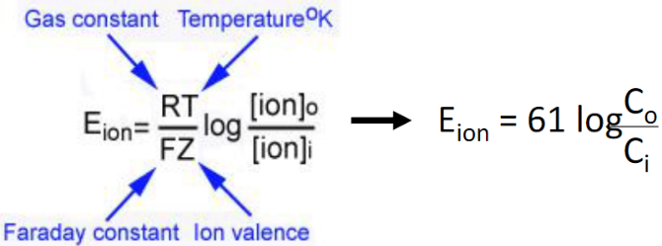**Equilibrium potential**: the membrane potential for a specific ion concentration such that the chemical and concentration gradient for that ion balances out (no net movement)
  + −90 mV for K+, +61 mV for Na+, −70 mV for Cl−, +120 mV for Ca2+
  + RMP tend more towards K+’s equilibrium since it is more permeable
* Excitable tissues (nerve and muscle) can rapidly change membrane potential (by altering membrane permeability to certain ions) to produce electrical signals
  + Generally, permeability is altered through (1) changes in electrical field (2) chemical messengers (3) stimulus (4) spontaneous change in potential
* Channels: **leak** (open all the time) vs **gated** (open or closed) channels, gated can be **voltage**, **chemically**, **mechanically**, or **thermally** gated

1. **Graded Potentials**

* Slight change in membrane potential, often caused by opening Na channels
  + More Na channels opening => higher potential
* Causes current and spreads to nearby areas **passively**, potential decreases with distance; signal can only travel **short distances**
* Diagram, schematic

  Description automatically generated**No refractory period**, can lead to action potentials (which have refractory period)

1. **Action potentials**

* Brief, rapid, large changes in membrane potential
* Controlled by voltage-gated Na ad K channels
* Graphical user interface

  Description automatically generated with low confidenceDiagram

  Description automatically generated**Threshold potential**: all-of-none trigger, signal **strength determined by frequency**
  + (1) **rapid opening of Na activation gates**, Na enter => depolarization
    - Positive feedback loop
  + (2) **slow closing of Na inactivation gates**, halts Na entry after delay
    - Unlike variable duration of graded potential, the duration of an action potential is always the same in a give cell
  + (3) **slow opening of K gates**, K exits => repolarization and hyperpolarization
    - As potential returns, changing voltage shifts the Na channels to closed-but-capable-of-opening, ready to respond to another triggering event
    - K channels also close and the membrane channels returns to resting state
* **Restoration**
  + Long-term: Na-K pumps maintain the concentration gradients
  + Short-term: only about 1 out of 100 000 K & Na ions move, no need to restore

1. **Summation (spatial/temporal/excitatory/inhibitory)**

* **Grand postsynaptic potential** (GPSP): EPSP (excitatory postsynaptic potential) and IPSP (inhibitory postsynaptic potential) are additive, leading to GPSP and potentially AP
  + **Temporal summation**: same place one after another (overlaps slightly each time)
  + **Spatial summation**: different places simultaneously
  + Up to 50 different summations can be required to trigger an action potential

1. **Synaptic Transmission**

* **Neuron**
  + **Input zone**: dendrite and cell body; **trigger zone**: **axon hillock**, only place action potential can initiate; **conducting zone**: axon; **output zone**: axon terminal
  + Typically, regions of excitable cells where graded potentials take place do not undergo action potentials (sparse Na channels). However, graded potentials can, before dying out, trigger action potentials in adjacent portions of the membrane
* **Propagation** (within one cell, between cells is synapse)
  + Within one cell – conducting zone, current spread passively to reach threshold of nearby areas, which then triggers Na channels
    - **Contiguous** (not myelinated) or **saltatory** (myelinated, channels concentrate at node of Ranvier, current “jumps”) conduction
    - one way only, **refractory period**: absolute (Na channels inactivated) vs relative (right after, Na channels capable but threshold hard to reach)
    - diameter & myelination effects speed
* 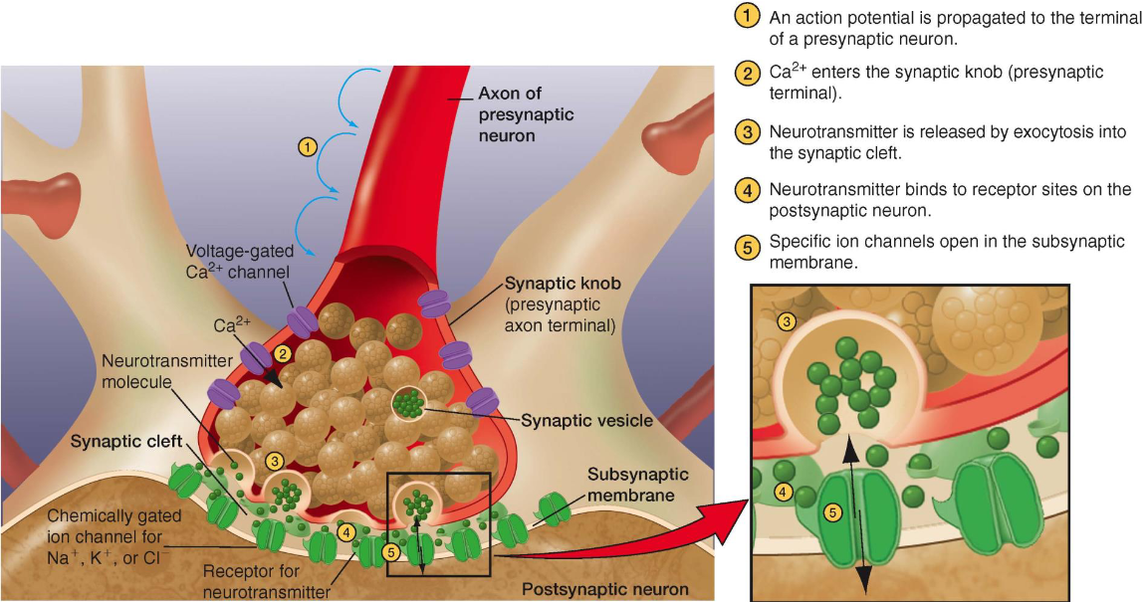**Synapses**: connection between two neurons, specifically between the axon of the presynaptic neuron and the dendrite / cell body of the postsynaptic neuron
  + **Synaptic cleft**: gap between the neurons, only 0.02 um but do not touch
  + **Synaptic knob**: contains synaptic vesicles
    - **Synaptic vesicles**: release neurotransmitters
    - **Calcium channels** open when the action potential arrives, let calcium ions into the cell (causes the release of synaptic vesicles)
  + **Neurotransmitters**: binding to receptor proteins on postsynaptic neuron that trigger ion channels and changes permeability (chemically gated!)
    - Each synapse releases only one neurotransmitter
    - **Excitatory**: trigger Na and K channels, slightly depolarize the postsynaptic neuron so its closer to threshold (rarely directly triggers AP)
    - **Inhibitory**: trigger Cl or K channels, slight hyperpolarize the postsynaptic neuron so its further away from threshold
    - Same NT can be excitatory or inhibitory based on the receptor proteins
  + **Neuropeptides**: large molecules released in a similar way to neurotransmitters
    - **Neuromodulators**: doesn’t cause potential change but acts on the synapse (Ex. changes sensitivity to certain neurotransmitter)
  + After the transmission neurotransmitter are either diffused away, inactivated by enzymes, or reabsorbed by the presynaptic neuron
* Presynaptic facilitation / inhabitation: changes behaviour of presynaptic neuron (Ex. make less Ca enter)